Ref: FDEHS/REP09-21/OCT/2022

EHS INTERNAL AUDIT REPORT 2022

Document Control Sheet

Title of Document : | EHS Audit Register
Document No. : | KU – FD – EHS – REG – 20
Issue No. : | 09
Issue Date : | 21/10/2022
Revision No. :
Revision Date :

Activity | Name / Designation | Signature | Date
Prepared by | Roberto Macahig  Labs Safety Specialist |  | 21/10/2022
Reviewed / Updated by | Navaz Kannu  Labs Safety Senior Specialist | 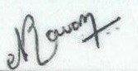 | 21/10/2022
Approval & Issue by | Dr.Fatima  Manager EHS |  | 21/10/2022

TABLE OF CONTENTS

1. Objective: 4
2. Scope: 4
3. Criteria: 4
4. Audit Report: 4
Introduction 4
Management Summary 5
Areas Assessed & Findings 5
Nonconformities Arising from this Assessment 8
Conclusion 12
5. Annexure: 12

- Objective:
The objectives of audit plan are to determine the following:
- Determine of conformity of Occupational Health and Safety Management system (OSHMS), ISO 45001, ISO 14001 with audit criteria.
- Govern the capability of OSHMS to ensure compliance with statutory, regulatory, or other requirements.
- Evaluate the effectiveness of OSHMS to achieve the defined objectives, to verify that implemented OSHMS continues to meet specified requirements and is being effectively maintained.
- Scope:
The scope of audit plan applies to all activities, products and services under the direct control of Khalifa University Main and SAN campuses. It reads provision of teaching and research in technology and science and application of knowledge services for the year of 2021.
- Criteria:
The criteria are to demonstrate conformity with Abu Dhabi Occupational Safety and Health System Framework V3.1 (OSHAD-SF V3.1), ISO 14001:2015, ISO 45001:2018, ISO 50001:2018, relevant environment, health and safety legislation, assure conformity with the environment, health and safety policy and seek continual improvement in the management system.

OSHMS audits are periodically carried out as per KU internal and external audit procedure. The procedure describes the method of:
- Conducting document review.
- Preparation for On-site Audit activities.
- Conducting the Audit by opening the meeting.
- Executing Audit.
- Collecting objective evidences.
- Reporting Audit Findings in “Improvement Action Report (IAR) Form”.
- Submission of IAR copies of reported findings.
- Closing Meeting.
- Audit Report:

Introduction

This report has been compiled by internal independent and skilled audit team lead by certified lead auditor as detailed below:

Auditor | Role | Audit date
Dr. Fatima Al Faqeeh  Navaz Kannu  Ahammed Padinjare  Roberto Macahig  Sultan Al Hemiri  Nadia Al Blooshi | Lead Auditor  Auditor  Auditor  Auditor  Observer  Observer | 17 – 20 October 2022
The objective of the assessment was to conduct a surveillance assessment and look for positive evidence to ensure the elements of the scope of certification and the requirements of the management standard are effectively addressed by Khalifa University's management system and to confirm the on-going achievement and applicability of the forward strategic plan.

Audit Summary

Any minor / major nonconformity that have been identified will need to be addressed or corrective plan shall be obtained.
The areas assessed during the course of the visit were generally found to be effective. The total numbers of findings were ninety-three, varies between minor and opportunity for improvement.
A minor nonconformity relates to a single identified lapse in the management system. A major nonconformity indicates a breakdown in the management system's ability to effectively control the processes for which it was intended. It is necessary to investigate the underlying cause of any nonconformity to determine corrective action. The proposed action will be reviewed for effective implementation at the next assessment. Refer to Appendix 5.2 for details of the audit findings.
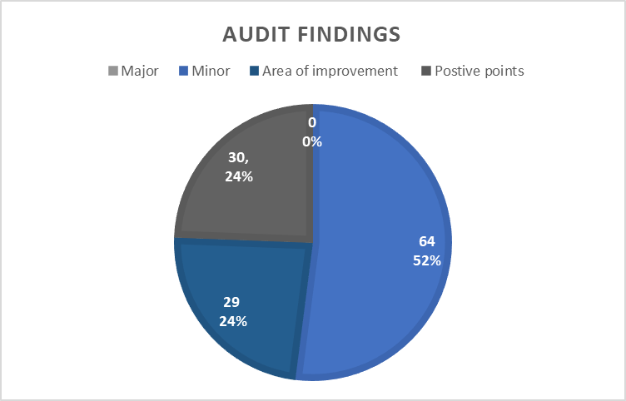
Findings | Classification
Positive Points | 30
Major Non-conformity | 0
Minor Non-conformity | 64
Area for Improvement | 29

Areas Assessed & Findings

This assessment included interview, document review and a site tour of Main and SAN Campuses building offices, storage area, workshops, researches and laboratories.
The management had shown a high level of commitment in compliance with KU EHS policies and procedures.
The system has been implemented and maintained, however, there are certain non-conformity and area of improvement had been noticed.

Positive points:
Lab Safety | New lab is being set up in compliance to EHS standards.
Lab Safety | Lab door signage updated with lab engineer details.
Lab Safety | The fume hoods and Biological safety cabinets were calibrated.
Lab Safety | PPE’s required for lab activities are available
Emergency Management | Emergency contact number posted on the lab.
Emergency Management | Site Specific business continuity was evident during the audit
Emergency Management | Site specific ERP was available during the Audit
Emergency Management | The different emergency scenarios along with response procedure explained to all students on the first class of the lab.
Emergency Management | Spill kit & First aid box available
Emergency Management | Energy efficient lab equipment / accessories procured for labs.
Training, Awareness and Competency | Student participant acknowledgement form signed and documented.
Training, Awareness and Competency | Training records of all lab users are available
Training, Awareness and Competency | Competent Fire warden and First aider were evident during the audit
Operational planning and control General | Plumbers’ Hepatitis-B Vaccination details are available with the site team during the audit
Operational planning and control General | Portable Appliance Test (PAT) for office equipment’s was found out during the audit.
Inspection | Self-Inspection are conducted by lab engineer regularly
Inspection | Half-yearly self-inspection by lab engineers carried out
Risk Management | Risk assessment – General, specific & task specific risk assessment were all filed in a folder
Measurement control | The PPM/Validation/servicing records of all lab equipment carried out as per manufacturers guidelines.
Measurement control | Monitoring & Measurement equipment’s calibration data are available.
Measurement control | PTW system is maintained and supporting documents was available during the audit.
Measurement control | Subcontractors MSRA was available during the audit
Internal audit | Internal audit report and closed out was available during the audit.
Document control | EHS documents all filed up with dividers and easily retrievable.
Waste Management | Waste disposed as per KU waste disposal procedure.
Communication | Monthly meeting organized with contractors to monitor EHS issues
Communication | Internal communication about OH&S is well organized and documented.
Contractor Management | Subcontractor audit carried out for major contractors
Roles and Responsibilities | All lab engineers were available during the internal audit showing their commitment.
Roles and Responsibilities | Full cooperation from Lab Custodian Dr. Banu; Lab Engineer & researchers working in the lab.

Conclusion

The assessment was based on sampling and therefore nonconformities may exist which have not been identified.
Next audit should include different activities and locations, corrective action report to be followed as per the audit procedure issued.
- Appendix:
- Audit plan.
- Audit Findings

Audit Plan

Audit Findings

